

Search

David Murphy

11 July [Growth](https://messapps.com/tag/growth/)

**Improving Your App: Today’s Top­Earning App Characteristics**

## [With only one exception, every top­grossing Google Play app is a gaming app. Unsurprisingly, each one of those gaming apps are also occupying the top­grossing list on Apple's App Store.](https://messapps.com/academy/app-store-comprehensive-analysis-2/)

**­ Apple App Store ­**

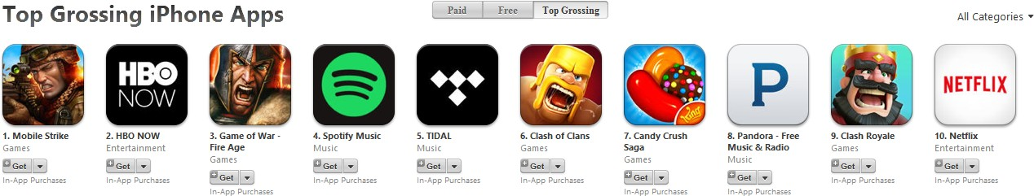

**NOTE** *Italicization* signifies an app that shares a top spot across both of major app stores

**Gaming: *Mobile Strike Clash of Clans***

***Game of War ­ Fire Age*** *Candy Crush Saga Clash Royale*

## Entertainment:

*HBO NOW* Netflix

## Music: Spotify Music Tidal

*Pandora ­ Free Music & Radio*

## ­ Google Play Store ­

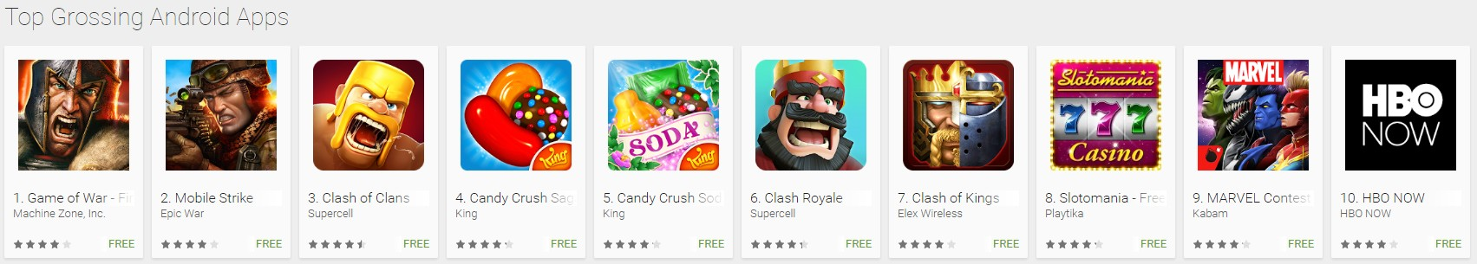

## Gaming:

### *Game of War ­ Fire Age* Mobile Strike

***Clash of Clans Candy Crush Saga***

**Candy Crush Soda Saga *Clash Royale***

## Clash of Kings

**Slotomania ­ Free Casino Slots MARVEL Contest of Champions**

**Entertainment:**

### *HBO NOW ­ Entertainment*

**­ Landing Pages/Websites ­**

13 out of the top 14 apps between the Android and iOS markets have a website that’s either designed for the sole purpose of advertising ­via [***App Indexing***](https://messapps.com/app-indexing-and-deep-linking/) ***­*** or are included in the main website via a [***Deep Link***](https://messapps.com/app-indexing-and-deep-linking/): **Gaming:**

Mobile Strike ­ [*http://www.mobilestrikeapp.com/*](http://www.mobilestrikeapp.com/)

Game of War ­ [*http://www.gameofwarapp.com/*](http://www.gameofwarapp.com/)

Clash Royale ­ [*https://clashroyale.com/*](https://clashroyale.com/)

Candy Crush Saga/Soda Saga ­ [*http://candycrushsaga.com/*](http://candycrushsaga.com/)

MARVEL Contest of Champions ­ [*http://playcontestofchampions.com/*](http://playcontestofchampions.com/)

Clash of Clans ­ [*https://clashofclans.com/*](https://clashofclans.com/) **|** [*http://supercell.com/en/games/clashofclans/*](http://supercell.com/en/games/clashofclans/)

Slotomania ­ [*https://www.slotomania.com/*](https://www.slotomania.com/)

Clash of Kings

## Music:

Spotify ­ [*https://www.spotify.com/us/*](https://www.spotify.com/us/)

Tidal ­ [*http://tidal.com/us*](http://tidal.com/us)

Pandora ­ [*http://www.pandora.com/*](http://www.pandora.com/)

## Entertainment:

Netflix ­ [*https://www.netflix.com/*](https://www.netflix.com/)

HBO NOW ­ [*http://play.hbogo.com/*](http://play.hbogo.com/)

## ­ Design ­

**Progression systems:** gaming apps are designed around a progression­based system. Similar systems are common in all areas of game development and many app developers are finding the approach exceptional for combating declining user retainment rates.

**Unlockable content:** each and every top­gaming app has this concept implemented. By requiring additional content to be earned, users are given a natural and rewarding incentive to continue playing each game.

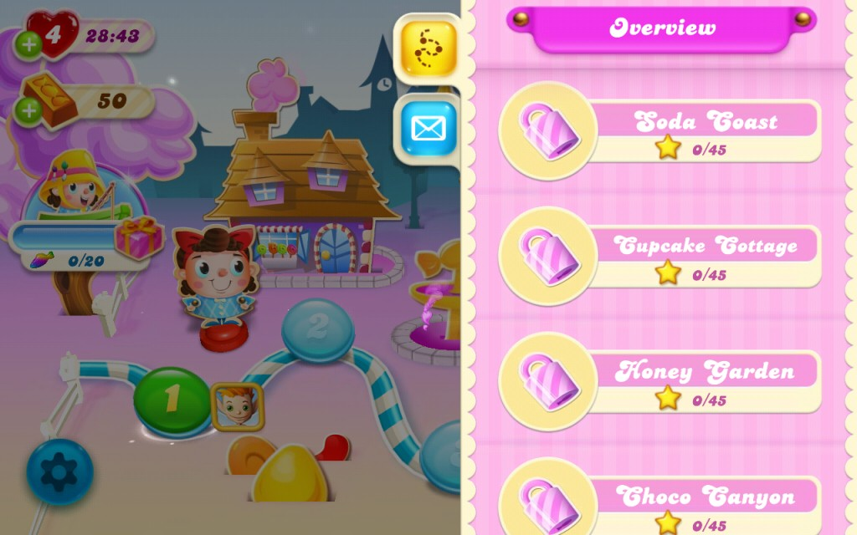

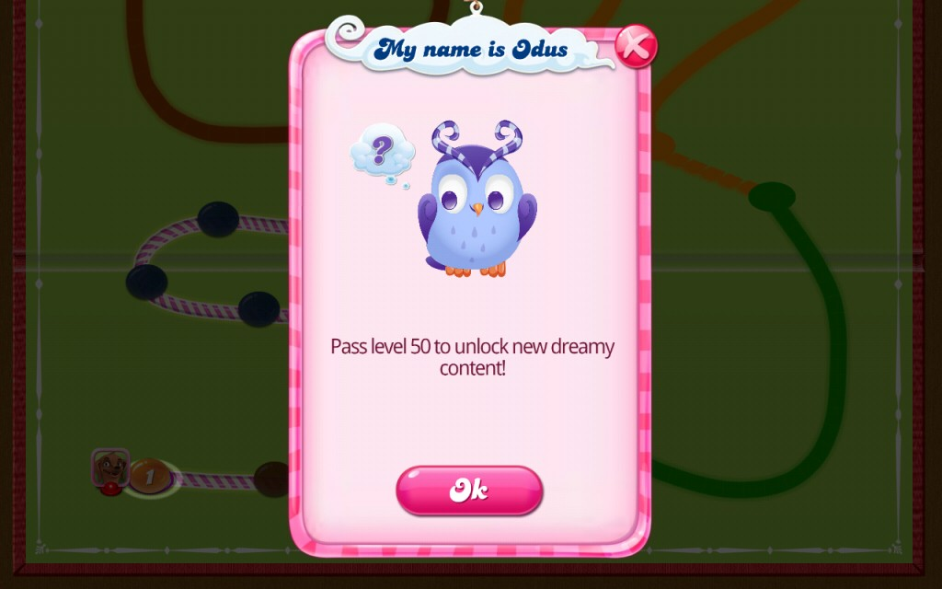

## ­ Push Notifications ­

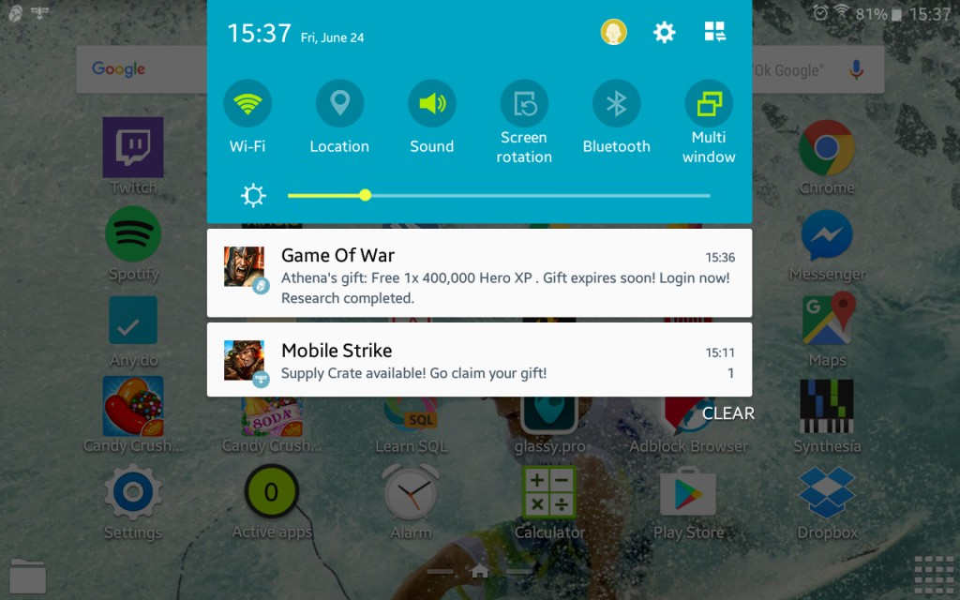

**­ Social implementations ­**

Whether it's to indirectly advertise their app by means of helping users share their progress with others or to help them invite their Facebook friends to play directly with or against, social implementations have given every top gaming app a clear­cut marketing advantage above the the rest of the competition.

## Creating an app that allows users to post their progress or to invite their friends on social media is essentially like creating an app that can market itself.

The top gaming apps prove that, if you have a great app, then compelling users to share it with their friends will be an easy feat; all that's required is that you provide the tools for them to do so:

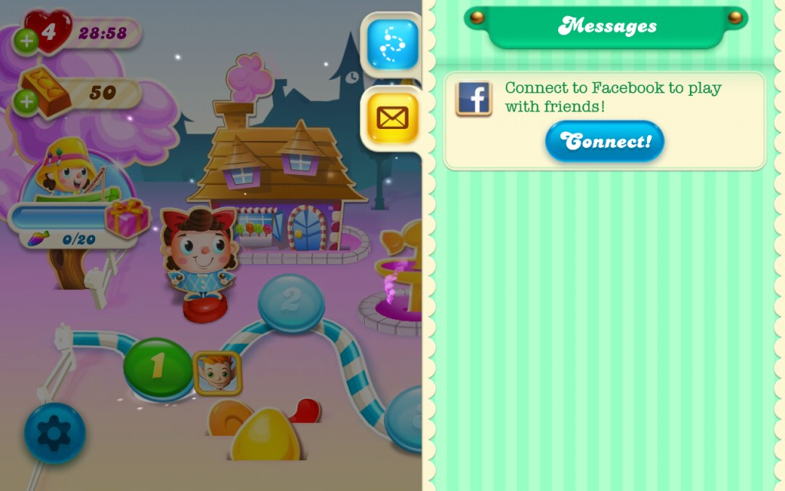

Most of the developers behind these top gaming apps are enabling communities to form around their app. **Two of the major variables that each app stores’s ranking algorithm factors in is how frequently users both log in and remain**

## active. If users are constantly engaging with the app, even if it’s just to message a friend, your ranking will increase in response to increased user activity.

Providing tools for communities to grow both within and around your app gives users the chance to utilize the app itself as a central hub where they can interact and even form alliances with each other.

Even if they don't feel an urge to just play the game itself, incentivizing user interaction within the app gives users a reason to log­in; realizing the potential for growth behind user interactions, some developers have done just that:

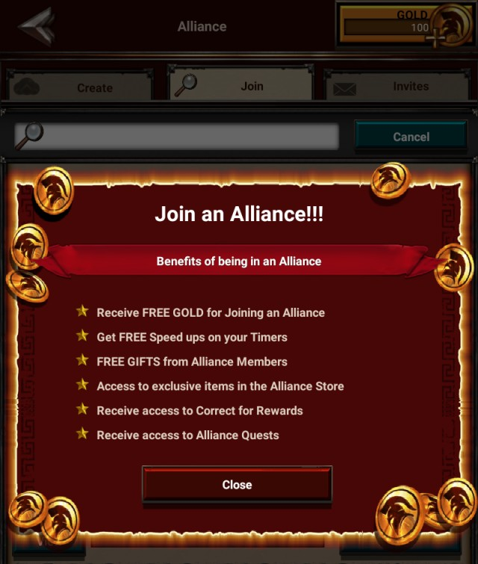

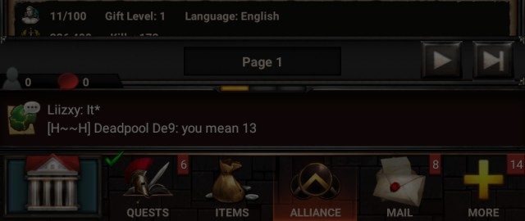

Game of War (Developed by Machine Zone, Inc.)

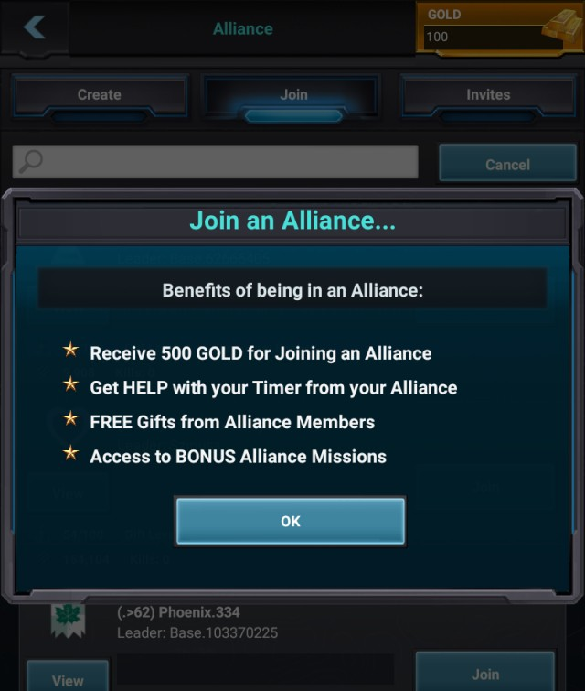

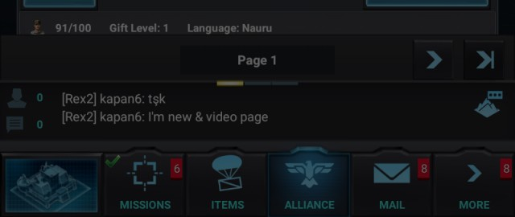

Mobile Strike (Developed by Epic War)

## ­ Marketing ­

Most people nowadays turn to social media to keep themselves in the loop. Most of these outlets have changed into what seems more like a hotbed for new and interesting trends. Realizing this, major app developers have carefully weaved Facebook implementations into their apps in a seemingly non­obtrusive way to make the ease of spreading their apps as seamless as the implementations themselves.

## Social Media (From Highest to Lowest Facebook Likes):

**Candy Crush**: Facebook = 75,000,000+ Likes | Twitter = 154,000+ Followers

**Slotmania:** 14,000,000+ | 12,000+

**Clash of Kings:** 3,600,000+ | 160,000+

**Clash Royale:** 750,000+ | 219,000+

**MARVEL Contest of Champions:** 625,000+ | N/A **Mobile Strike**: 500,000+ | 15,000+ **Game of War**: 160,000+ | 108,000+ Every gaming app has a Facebook page, yet some are so deeply integrated within Facebook that they’re available to play directly on user Facebook profiles from a computer or laptop device:

Candy Crush: [*https://www.facebook.com/candycrushsaga/*](https://www.facebook.com/candycrushsaga/)

Clash of Kings: [*https://www.facebook.com/Clash.Of.Kings.Game*](https://www.facebook.com/Clash.Of.Kings.Game)

Slotomania: [*https://www.facebook.com/slotomania/*](https://www.facebook.com/slotomania/)

On the other hand, some are not. Instead, clicking the “Play Game” function on their respective Facebook pages redirects browsing users to the app’s landing page.

Game of War: [*https://www.facebook.com/GameofWar/?fref=ts*](https://www.facebook.com/GameofWar/?fref=ts)

Mobile Strike: [*https://www.facebook.com/MobileStrike/*](https://www.facebook.com/MobileStrike/)

Clash Royale: [*https://www.facebook.com/ClashRoyale/?fref=nf*](https://www.facebook.com/ClashRoyale/?fref=nf)

MARVEL Contest of Champions: [*https://www.facebook.com/marvelcontestofchampions/?fref=ts*](https://www.facebook.com/marvelcontestofchampions/?fref=ts)

The outlier, however, is the method engineered by Mobile Strike's developers: by clicking “Send to Mobile” from the app’s Facebook

page, a push notification is sent to the user's mobile device. Once opened, the notification sends users to the Mobile Strike’s app page on either the App Store or the Play Store (device depending).

Mobile Strike: [*https://www.facebook.com/games/fbs=1101&app_id=342076679289388*](https://www.facebook.com/games/?fbs=1101&amp;app_id=342076679289388)

## ­ Prices ­

Every app on the top­grossing list is free of charge. How is that possible? They’re what’s commonly referred to as “freemium apps.” [*Freemium refers to a model for revenue acquisition in which the most basic rendition of the service is free of charge, and additional services that improves user experience can be paid for.*](https://messapps.com/freemium-magic/)

## ­ In­app purchases ­

**Gaming**

Each and every top­gaming app offers a variety of purchasable in­game currency that's designed to save users the most invaluable resource of all; **time**. A small purchase or “micro transaction” is enough to speed­up a user's progression, helping them

earn unlockable content and other rewards. Notice the similarities below: **Candy Crush**

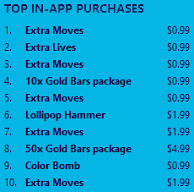

## Clash of Clans

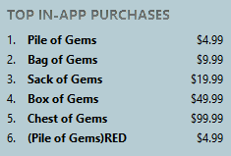

**Clash Royale**

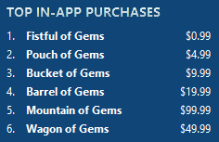

**Game of War**

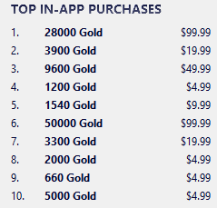

**Mobile Strike**

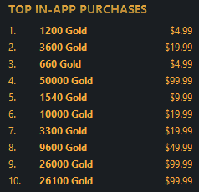

**Entertainment & Music**

Every non­gaming app is built around a media service that requires high amounts of constantly streaming data ­ a service that’s better fit for a computer or a laptop. Given that services such as Spotify and HBO GO were already popular before becoming mobile apps, the conveniences offered by mobile devices makes these apps seem more like a marketing tool for the desktop­oriented services from which they are derived.

## Spotify

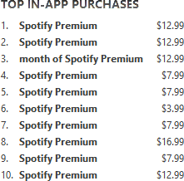

**Pandora**

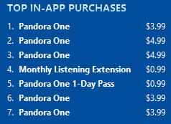

**Tidal**

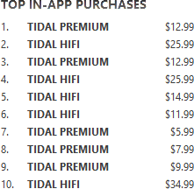

The biggest takeaway is discerning just how effective these freemium gaming strategies are, and how it ­ coupled with social media implementations ­ effectively ushered in the gaming category’s rise to complete app store domination.

 0

You might also like this articles

Dominick Wojtas



21 May

# [Why apps get rejected](https://messapps.com/academy/articles/apps-get-rejected/)

The App Store is every iOS developer’s best friend until your app is rejected, and then it quickly becomes your

David Murphy

05 July

# [Simple & Effective Ways to Gain App Publicity](https://messapps.com/academy/simple-effective-ways-gain-app-publicity-2/)

enemy. Ensuring your app will be accepted by the App Store review process *before* submission is essential for every app developer. A rejected app can not only be a bad finish to a smooth development process but it can also cause unnecessary delays.



0

There are hundreds of thousands of apps out there. Having an amazing app is no longer enough. Only those that can evoke the most attention will have

a chance at scaling the charts.

0